**First Test in TestNG**

Now let us start scripting using TestNG. Let us script for the same example that we used for understanding the WebDriver. We will use the demo application, www.calculator.net, and perform percent calculator.

*In the following test, you will notice that there is NO main method, as testNG will drive the program execution flow. After initializing the driver, it will execute the '@BeforeTest' method followed by '@Test' and then '@AfterTest'. Please note that there can be any number of '@Test' annotation in a class but '@BeforeTest' and '@AfterTest' can appear only once.*

package TestNG;

import java.util.concurrent.TimeUnit;

import org.openqa.selenium.*;

import org.openqa.selenium.firefox.FirefoxDriver;

import org.testng.annotations.AfterTest;

import org.testng.annotations.BeforeTest;

import org.testng.annotations.Test;

public class TestNGClass

{

WebDriver driver = new FirefoxDriver();

@BeforeTest

public void launchapp()

{

// Puts an Implicit wait, Will wait for 10 seconds before throwing exception

driver.manage().timeouts().implicitlyWait(10, TimeUnit.SECONDS);

// Launch website

driver.navigate().to("http://www.calculator.net");

driver.manage().window().maximize();

}

@Test

public void calculatepercent()

{

// Click on Math Calculators

driver.findElement(By.xpath(".//*[@id='menu']/div[3]/a")).click();

// Click on Percent Calculators

driver.findElement(By.xpath(".//*[@id='menu']/div[4]/div[3]/a")).click();

// Enter value 10 in the first number of the percent Calculator

driver.findElement(By.id("cpar1")).sendKeys("10");

// Enter value 50 in the second number of the percent Calculator

driver.findElement(By.id("cpar2")).sendKeys("50");

// Click Calculate Button

driver.findElement(By.xpath(".//*[@id='content']/table/tbody/tr/td[2]/input")).click();

// Get the Result Text based on its xpath

String result = driver.findElement(By.xpath(".//*[@id='content']/p[2]/span/font/b")).getText();

// Print a Log In message to the screen

System.out.println(" The Result is " + result);

if(result.equals("5"))

{

System.out.println(" The Result is Pass");

}

else

{

System.out.println(" The Result is Fail");

}

}

@AfterTest

public void terminatetest()

{

driver.close();

}

}

**Execution**

To execute, right click on the created XML and select "Run As" >> "TestNG Suite"

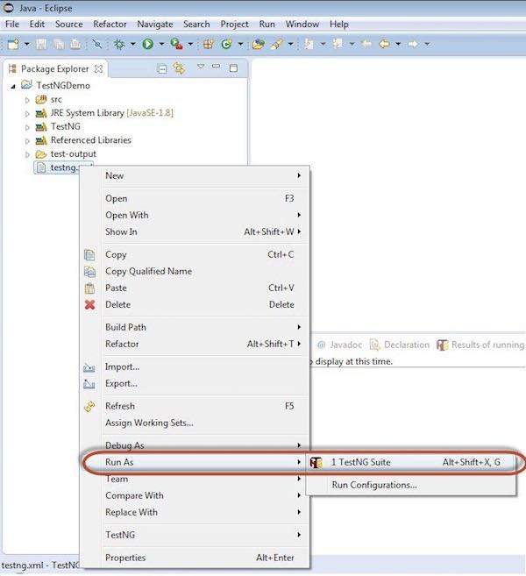

**Result Analysis**

The output is thrown to the console and it would appear as shown below. The console output also has an execution summary.

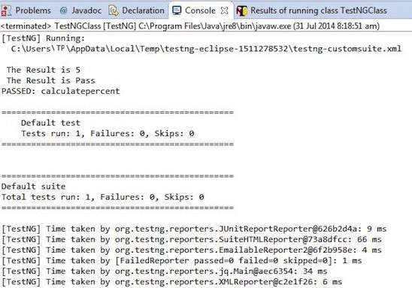

The result of TestNG can also be seen in a different tab. Click on 'HTML Report View' button as shown below.

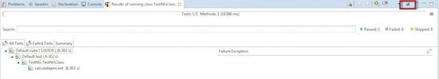

The HTML result would be displayed as shown below.

